Name:
Block:
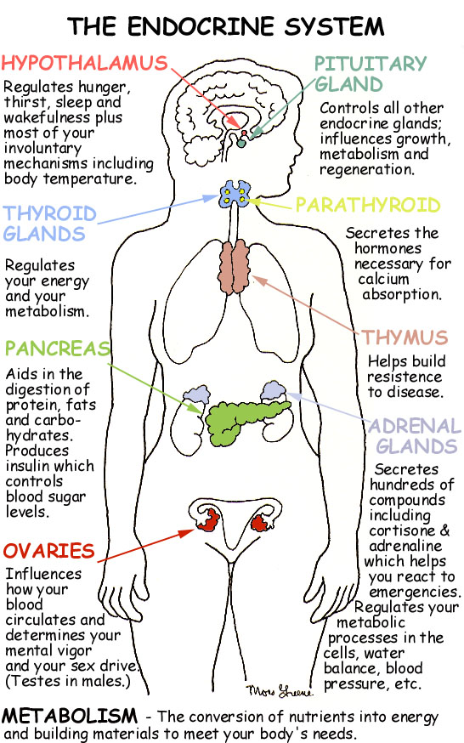
SWBAT define the function of the endocrine system and explain the role of glands and hormones.
So you know that the nervous system regulates fast changes in the body in response to inputs from the environment. What regulates growth? What about sleep or mood or metabolism? It isn’t the nerves. It’s an entirely different messaging system called the endocrine system. Based on the visual, how do you think the endocrine system works?

Endo means…
-Crine means…
So endocrine means…
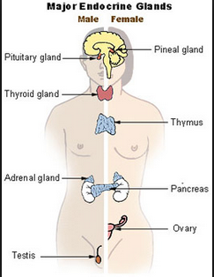
Read, Write, Form Connections and Opinions!
GLANDS & HORMONES
Glands are groups of cells that all work to secrete (produce, or send out) a substance in the body. These substances can be anything from things we can see, such as mother’s milk or sweat to things we cannot see, such as hormones. Generally, in the endocrine system, glands secrete different types of hormones—or chemical signals (messages)—directly into the blood stream.
THE ENDOCRINE SYSTEM
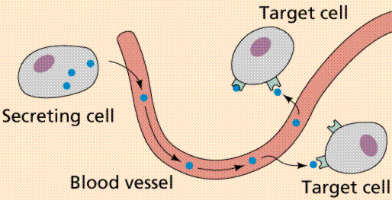
The word endocrine breaks down into two Greek words, with –endo meaning “inside” and crinis meaning “to secrete.” The hormones act as chemical messengers that regulate systems in the body. The hormones almost always have a target tissue that they affect. For example, the thyroid gland controls how quickly the body uses energy, how many proteins the body makes, and how sensitive the body is to other hormones. Since these are very general functions, it might make sense that the thyroid generally targets all cells in the body. An example of a more specific gland is the pineal gland, which secretes a hormone that targets cells sensitive to lighting. The endocrine system is a messaging system that effects the changes in your body that are slow and long term. The difference between the endocrine system and the nervous system is mainly that the nervous system acts as a quick message transmitter that manages short term changes, while the endocrine system acts as a slow message transmitter that regulates long term change. The endocrine system has 8 major glands: hypothalamus, pituitary, thyroid, parathyroids, adrenal, pineal, reproductive (ovaries and testes), and the pancreas. All of the glands secrete different hormones and regulate different processes in the body.
A gland is…
- What do glands do?

- Into which organ system do glands release hormones?

- Are all glands the same?

- What does specialized mean?

- What is interesting about the composition of a gland?

- Where can endocrine glands be found?

A hormone is…

- What is the general function of a hormone?

- Are all hormones the same?

- How do endocrine hormones travel the body?

- What other organ systems to hormones affect?

- What is the difference between the endocrine system and the nervous system?

- What is the function of the endocrine system?

- Why is the endocrine system important to the body?

- Given what you know, make some guesses as to what in your life the endocrine system regulates.

Independent Practice/Life’sWork
Best Guess? Nervous System or Endocrine System? Identify which situations are endocrine regulated and which are nervous regulated.
- ________________ You getting tired when it gets dark outside.
- ________________ How fast you can run.
- ________________ Deciding to drive your car instead of walk to the super market.
- ________________Undergoing puberty
- ________________Cells dividing when you grow up
- ________________How much weight you put on when you hit 50 years old
- ________________The decision to do your homework or not.
- ________________Brushing your teeth in the morning.
- ________________Taking a test
- ________________The speed of your metabolism
- ________________The oiliness of your skin
- ________________The sound of your voice
- ________________The size of your shoe
Stretch your thoughts Challenge yourself to write the most descriptive paragraph (3-5 sentences) describing what the endocrine system does and what it includes. Prize goes to for the best written paragraph in each class!

Challenge Yourself!
Which of the following endocrine glands do you think are involved in the physical changes you undergo during puberty? Why do you think so?

CLOSURE Connect the word gland to as many words or concepts as you possibly can.

GLAND

