Any living thing that can carry out life processes independently is called an organism. There are two types of organisms: unicellular and multicellular.
Unicellular organisms are made up of one cell
- Prokaryotes like bacteria are unicellular.
- A unicellular organism needs fewer resources and can live in harsher conditions than organisms that have many cells.
Multicellular organisms are made up of many cells.
- Multicellular organisms start out as a single cell. As the cell develops into many cells, it becomes differentiated, or fixed, into different types of cells.
- Multicellular organisms are made up of one or many cells and can have a larger size and a longer life than unicellular organisms
How are multicellular organisms more efficient than unicellular organisms?
______________________________________________________________________________________________________________________________________________________________________________________________________________________________________________________________________________________________________________________________
There are four levels of organization in multicellular organisms: Cells, tissues, organs, and organ systems
- Cells can have specialized structures and functions. For example, a muscle cell or bone cell or guard cells and stoma cells in plants
- A tissue is a group of similar cells that perform a common function. For example, nerve tissue, muscle tissue or transport tissue in plants.
- An organ is a collection of tissues that carry out a specialized function in your body. For example, the heart or the stomach or the leaf in a plant.
- An organ system is a group of organs that work together to perform body functions. For example, the digestive system or the root system in plants
List and describe the four levels of organization in multicellular organisms?
_______________________________________________________________________________________________________________________________________________________________________________________________________________________________________________________________________________________________________________________________________________________________________________________________________________________________________
Directions: Define each level of organization using your notes

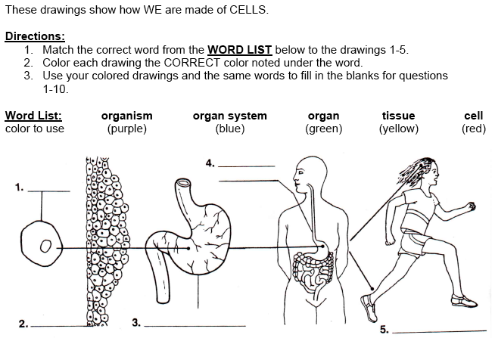
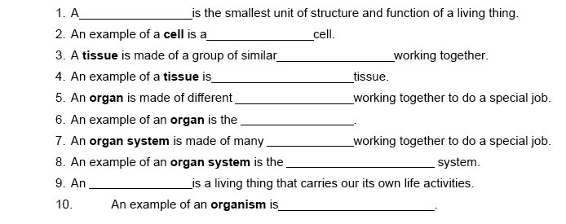

EXIT TICKET BCR:
Describe the four levels of organization in multicellular organisms:
Brainstorm!

____________________________________________________________________________________________________________________________________________________________________________________________________________________________________________________________________________________________________________________________________________________________________________________________________________________________________________________________________________________________________________________________________________________________________________________________________________________________________________________________________________________________________________________________________________________________________________________________________________________________________________________________________________________________________________________________________________________________________________________________________________________

